
Cal Poly
California Polytechnic State University, San Luis Obispo, CA 93407

    In Brief  - For a college enrollment system, PASS has the look , feel, and usability of a website that was created as an afterthought  - When you visit PASS, it is apparent that there are many things that need polishing, even to an untrained eye  - PASS turns something that should be relatively easy to do with a well designed website to something that you have to spend hours on just to get the hang of
  PASS or Fail
  Memorandum
  Date: April 7, 2009
  To: Sherrie Amido
  Fr: Cal Poly PASS Task Force
  Re: PASS Website Analysis
  
  Students Using the PASS Website
  Once every ten to twelve weeks, Cal Poly students are required to plan a new schedule for the upcoming quarter. All Cal Poly students have to use PASS. Many students have had problems with it, whether it was trying to switch between two different schedules to compare them, having to transfer information from PASS to CPREG to register, or timing out just before you save your schedule. We believe that PASS is a very useful tool but there are still many flaws in the website. This report will explore and examine these flaws, and also propose ways to fix them in order to make PASS a more accessible, comprehensive, and easy to use website. By doing so students will be able to complete their schedules more quickly, and in some cases our proposals may even help students to enroll in classes they would have otherwise missed.
  Time Taken to Create a Schedule
  It takes an average student 4 minutes to get to the completed schedule to save on pass, and normally students will have 5-20 schedules to choose from, 4 minutes is just to check one. The number of clicks to get to a single schedule with 4 classes and availability selected and saved is 32. It is 32 without correcting
California Polytechnic State University Report: PASS or Fail page 2

the schedule. With the proposed improvements listed below, the number of clicks is reduced to 16 and the time spent is reduced to 2 minutes and 30 seconds.

Figure 1: The PASS website, selecting your availability

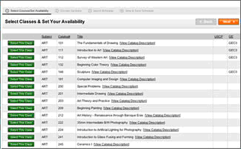

Source: http://www.amazingcube.com/wp-content/uploads/2007/01/portfolio_pass.jpg

Availability

When you set your availability on PASS it will uncheck and gray out the classes that don’t fit within your time frame, on the next page. However, it does not uncheck classes that are in your availability time frame but have required labs or lectures associated with a class that aren’t in your time frame. PASS will not let you continue until you manually find and uncheck all of the associated courses. With better coding, the site should not include classes with lectures or labs that aren’t within your availability.

The site should give an option to uncheck all classes and uncheck all full classes.

Also, to add to the site the availability should be moved to the second page with the list of classes the student has selected. By doing this the student don’t have to navigate away from the list of classes and lose their current selection if they wish to change their availability.

Schedule Format

The Select Schedule Section, page 3 on PASS, should allow students to view their schedules in different ways. Right now it is just a vertical list format. By allowing students to view multiple schedules at once, they can compare a select group of schedules and save them individually if the choose to.

One other viewing option could be a grid view, where the schedule time previews that are currently on the right side of the page, would be arranged in a grid format as if they were files on a computer with the window st to “view as grid.” This would make it much easier to choose schedules based on the class time and when coupled together with the ability to view multiple schedules at once on page 4, it would greatly improve the schedule choosing experience.

Right now you have to select each schedule individually to see what teachers are teaching. With a new layout students could first select schedules by time in a grid view. Then they could view the schedules they selected in a more informational view that is similar to page 3 on PASS now but with their teacher’s names added. This turns a multiple step process into just two easy selections.

California Polytechnic State University Report: PASS or Fail page 3

Figure 2: Addition to PASS, Flowcharts by Major

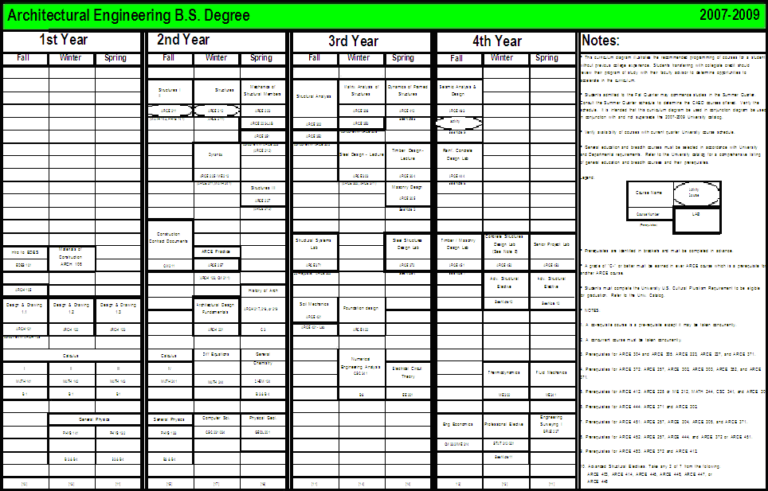

Source:ahttp://www.arce.calpoly.edu/student/documents/new07-09flowchart.pdf

Flowchart

Students should have access to their major’s flowchart. Also, PASS should allow an auto-fill feature based on the students major and that major's flow chart. This would be a feature in step 1 in the current PASS, so you could auto-fill the recommended courses then add or remove classes depending on what you want to take.

Web Design Flaws

To improve the format of the PASS website, adding more colors would to be more pleasing to the eye. ¹ The layout could also be improved, because it is hard to view on a smaller screen. The website should scale to make it easier to read.

The second page of PASS should contain a list of all possible classes, and this will reduce the height of the second page. To make PASS easier to view classes should be color coded according to closed and open classes, so that closed classes are highlighted in red and open classes in green. Color coding PASS will help students pick classes that aren’t closed quicker.

Proposal Outcomes

We wish to create a more accessible PASS with easier side-by-side schedule viewing and more up-to-date and accurate list of course instructors. Viewing your different schedule options should be easier, through our “grid-viewing” option. Additionally we will strive to combine PASS and CPREG to allow fewer hassles and greatly increase efficiency. Our services will include access to the various major's flowcharts with the option to auto-fill from required classes, user selected availability, and course offerings. This allows us to turn a once arduous process into a just few simple clicks.

End Notes

¹ Johnson-Sheehan, Richard. Technical Communication Today. 3rd ed. Longman, 2009, 365-3

